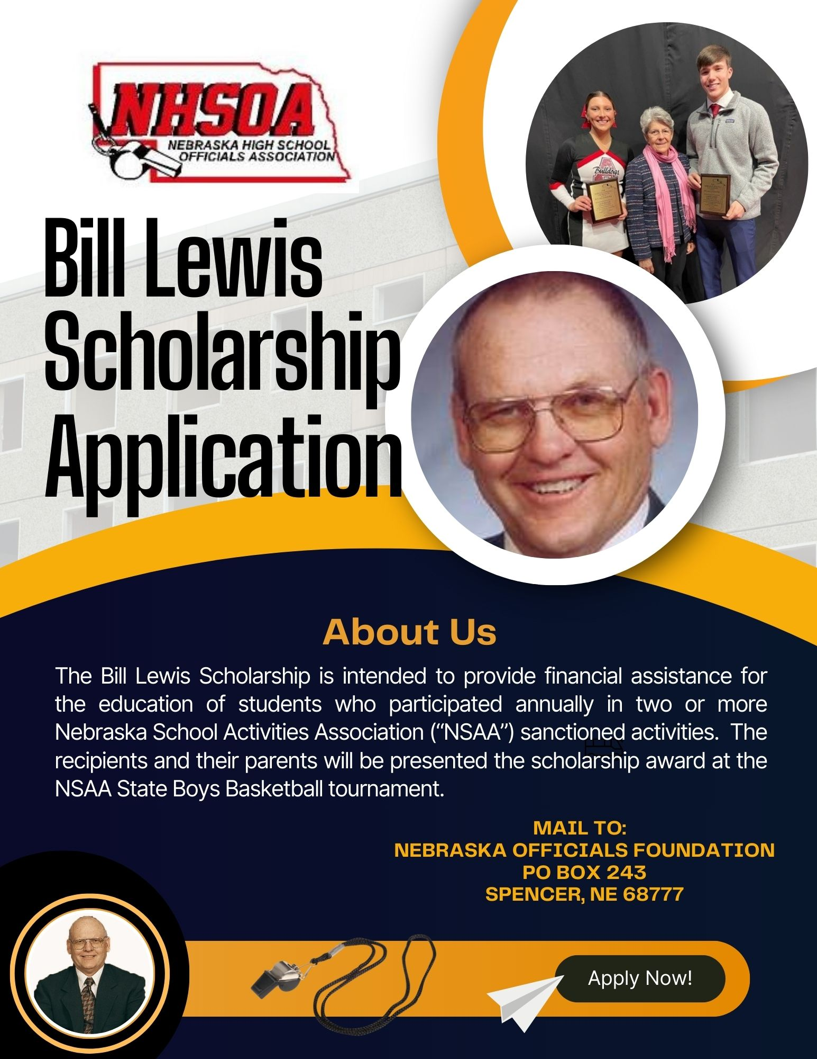

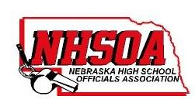
TO: High School Guidance Counselors
FROM: Nebraska Officials Foundation and Nebraska High School Officials Association
RE: Scholarship Opportunity

We are pleased to announce that the Nebraska Officials Foundation and Nebraska High School Officials Association will be awarding two $5000 scholarships this year.

Bill Lewis was the past NSAA Director of Officials and school administrator who dedicated his time and talents to improving the quality of and respect for sports officiating throughout Nebraska.

Mail to:

Nebraska Officials Foundation
PO Box 243
Spencer, NE 68777

As an alternative, the forms can be scanned and e-mailed to: Stadium_sports@hotmail.com

DEADLINE: February 19, 2024

Once the recipients are selected, they will be contacted and awarded their scholarship at the Nebraska School
Activities Association’s State Girls/Boys Basketball Championships.

Should an applicant have any questions, please have them contact the person listed below. Thank you in advance for your assistance!

Sincerely,
Kelly Classen
(402) 340-1045

BILL LEWIS SCHOLARSHIP APPLICATION
All requested information must be provided. If incomplete, your application may not be considered.
Please attach additional pages as needed to complete this application.

Name ______________________________________________________ Birth Date: ____________________________
Home Address:
Phone: _________________________________ E-mail Address:
Dates of Parent’s Registration as Official with NSAA (if applicable)
Parents’ Name _______________________________________Other Parent’s Name
Parent’s Home Address (if different)
High/Home School Attending ________________________________________ Graduation Date
GPA __________________________ ACT Score _______________________ SAT Score
(Please give GPA on the 1 – 4.0 (+) scale – you must convert if your school uses a percentage scale.)
Where do you plan to attend college?
What is your career field? __________________________________ Degree Sought
Why have you chosen this career field and why do you believe you will succeed?
____________________________________________________________________________________________________________________________________________________________________________________________________
Please tell us about your involvement in school and community activities (including officiating activities, if any)
__________________________________________________________________________________________________
Please list all additional scholarships, fellowships, grants, and other financial assistance for which you have applied and the status of said applications and amount of any awards.

*Please enclose a statement of your financial need for this scholarship and involvement in NSAA sanctioned activities.

Name and address of your local newspaper:

Signature _____________________________________________________ Date

Return to:

Nebraska Officials Foundation
PO Box 243
Spencer, NE 68777

OR

Email to:

Stadium_Sports@hotmail.com

BILL LEWIS SCHOLARSHIP APPLICATION

Information and Requirements

Purpose: The Bill Lewis Scholarship is intended to provide financial assistance for the education of students who participated annually in two or more Nebraska School Activities Association (“NSAA”) sanctioned activities. The recipients and their parents will be presented with the scholarship award at the NSAA State Boys Basketball tournament.

Eligibility: The Bill Lewis Scholarship program is open to all students to further their education. Providing guidelines are met.
- In the final year of secondary education (at time of application)
- Nebraska resident
- Active in NSAA activities for a minimum of 3 years
- Participation in a minimum of 2 NSAA sponsored activities annually.
- Attend accredited post-secondary school.

Amount and Use: Up to two (2) scholarships in the amount of up to $5000 each will be awarded which can be used for tuition, fees, books, and other qualifying expenses.

The scholarships will be paid directly to the educational institution you attend.

Selection Criteria: The Scholarship Committee will select the scholarship recipients, giving consideration to the following criteria: Financial need; citizenship; leadership, career goals; academic achievement (GPA, ACT or SAT scores); and involvement in NSAA sanctioned activities.

Scholarship Committee: The Scholarship Committee consist of members from the NHSOA Board

Submission Requirements:
1. An original signed application, official documentation of SAT or ACT scores and a statement of financial need.
2. An original transcript of the high school(s) or learning institution(s) must be sent directly from the school(s) to:

Nebraska Officials Foundation
PO Box 243
Spencer, NE 68777

Or Email to: Stadium_Sports@hotmail.com

Deadline for Submission:

Applications must be submitted by February 19th. Final selections will be announced by March 1st

